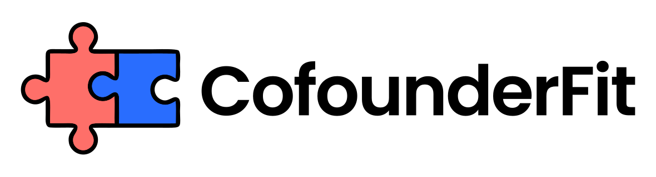
FOUNDER COMMUNICATION NORMS TEMPLATE
Prepared by CofounderFit
Replace assumptions about responsiveness and tone with editable norms the founders can test and improve.
Audience: Founder teams who work at different speeds, locations, or communication styles and need explicit expectations.
Generated: August 24, 2026

1. Channel map
Assigning a purpose to each channel keeps urgent requests visible and important context from being scattered.
- Urgent operational channel: [Channel]
- Decision and context channel: [Channel]
- Routine update channel: [Channel]
- Private founder topic channel: [Channel]

2. Response expectations
Shared response windows reduce anxiety without creating an unrealistic expectation of constant availability.
- Urgent response window: [Time and hours]
- Routine response window: [Time]
- Focus or offline periods: [Schedule]
- How to signal availability changes: [Method]

3. Written context
A minimum context standard helps founders make faster decisions and avoids re-litigating conversations that were never recorded.
- Required decision summary: [Format]
- Evidence or links to include: [Requirements]
- Owner and deadline notation: [Format]
- Location of final records: [Location]

4. Disagreement norms
Explicit disagreement norms make directness safer and set limits on behavior that damages the relationship.
- How to challenge an idea: [Preferred format]
- Behaviors that are out of bounds: [List]
- When to move from text to a call: [Trigger]
- How the final decision is acknowledged: [Method]

5. Confidential topics
Sensitive founder, employee, customer, and financing topics need tighter channel and sharing boundaries.
- Topics treated as confidential: [List]
- Approved participants: [Names or roles]
- Approved channel or storage: [Location]
- Rule for external sharing: [Approval process]

6. Norm review
Regular review lets the team adjust norms when workload, time zones, or company stage changes.
- First review date: [Date]
- Friction signal to examine: [Signal]
- Norm owner: [Name]
- Change experiment: [Action and duration]

Disclaimer
This template is a decision aid rather than legal, tax, or financial advice. Adapt it to your obligations, policies, and working context.

Next step
Use this document to structure the conversation, then validate cofounder compatibility before signing final terms or splitting equity.
Assessment: https://www.cofounderfit.com/assessment

