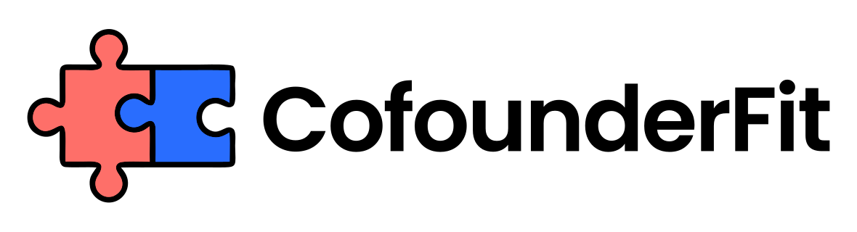
COFOUNDER TRIAL SPRINT PLAN
Prepared by CofounderFit
Run a contained, realistic collaboration test and finish with an explicit continue, pause, or stop decision.
Audience: Potential cofounders who want evidence from real work before making an equity or long-term commitment.
Generated: August 25, 2026

1. Hypothesis
A clear hypothesis makes the sprint a test of founder fit rather than a small project with no decision value.
- Partnership hypothesis: [What you believe]
- Critical uncertainty: [What must be learned]
- Behavior to observe: [Signal]
- Evidence that would change your mind: [Evidence]

2. Two-week outcome
A bounded outcome creates enough pressure and interdependence to reveal collaboration without creating premature commitment.
- Sprint dates: [Start and end]
- Customer or product outcome: [Deliverable]
- Success criteria: [Measures]
- Explicit non-goals: [List]

3. Work ownership
Defined ownership lets the founders observe reliability and handoffs instead of testing their tolerance for unclear roles.
- Founder A owns: [Work and decision boundary]
- Founder B owns: [Work and decision boundary]
- Shared decision: [Decision and rule]
- Dependency handoff: [Input, owner, and date]

4. Communication cadence
A simple cadence provides comparable evidence about communication while leaving enough space for focused execution.
- Daily update format: [Channel and time]
- Decision checkpoint: [Cadence]
- Urgent escalation channel: [Channel]
- Midpoint check-in: [Date and questions]

5. Friction observations
Recording concrete moments helps the debrief focus on workable patterns rather than general chemistry or hindsight.
- Unexpected disagreement: [Observation]
- Missed or changed commitment: [Observation]
- Response to uncertainty: [Observation]
- Repair or support behavior: [Observation]

6. Continue/pause/stop debrief
An explicit decision prevents a pleasant trial from drifting into equity and dependency without informed commitment.
- Evidence supporting continuation: [Evidence]
- Concern requiring a pause: [Concern and next test]
- Reason to stop: [Reason]
- Decision, owner, and next date: [Record]

Disclaimer
This plan is a decision aid, not legal, tax, or financial advice. Address IP, confidentiality, compensation, and other obligations with qualified advisors before the sprint.

Next step
Use this document to structure the conversation, then validate cofounder compatibility before signing final terms or splitting equity.
Assessment: https://www.cofounderfit.com/assessment

