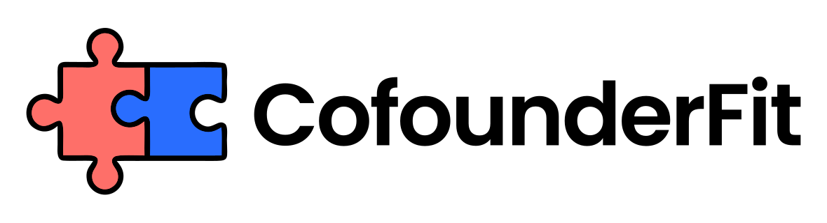
COFOUNDER TRIAL PROJECT TEMPLATE
Prepared by CofounderFit
Use the template to run a contained project, observe real behavior, debrief honestly, and validate fit before splitting equity.
Audience: Founders who like each other enough to test real work before making the partnership official.
Generated: August 17, 2026

1. Trial project goal
A cofounder trial project should be small enough to finish but real enough to create decisions, tradeoffs, and pressure. Define a concrete outcome and time box.
- Project name: [Name]
- Time box: [2 weeks / 4 weeks / custom]
- Outcome: [Prototype, customer interviews, landing page, sales test]
- Success criteria: [Measurable criteria]

2. Roles and working agreements
Assign clear owners before work starts. The trial should test how founders communicate, execute, and make decisions, not whether they can survive ambiguity created by a bad setup.
- Founder A owns: [Responsibilities]
- Founder B owns: [Responsibilities]
- Meeting cadence: [Days/times]
- Communication channel: [Slack, email, docs, calls]

3. Decisions to observe
Use the trial to watch the decisions that will matter after commitment. Capture examples as they happen so the debrief is concrete.
- How do we prioritize when time is limited?
- Who decides when we disagree?
- How do we handle missed commitments?
- How do we respond to customer or investor rejection?

4. Red flags and green flags
Before the trial starts, agree what would be a positive signal and what would require a pause. This makes the final decision less emotional.
- Green flags: [Examples of trust, clarity, ownership, repair]
- Red flags: [Avoidance, blame, unreliability, contempt, hidden agendas]
- Evidence log: [Where observations will be recorded]

5. Final debrief
End the trial with a structured conversation. The goal is not to prove perfection. The goal is to decide whether the friction is workable and worth formalizing.
- What worked better than expected?
- What created tension?
- What would need to change before equity?
- Do we continue, pause, or stop?

Disclaimer
This template is a collaboration planning aid. It is not legal advice and does not replace formal founder agreements, IP assignment, or advisor review.

Next step
Use this document to structure the conversation, then validate cofounder compatibility before signing final terms or splitting equity.
Assessment: https://www.cofounderfit.com/assessment

